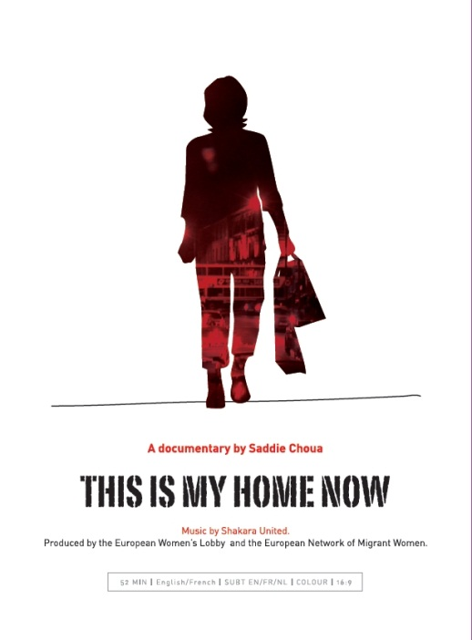
Visit the EWL and ENoMW websites to find out more about our work: www.womenlobby.org
www.migrantwomennetwork.org

To order the DVD, please fill in this form and return it to the European Women’s Lobby Secretariat by post or e-mail:
European Women’s Lobby
18 rue Hydraulique
1210 Brussels
Belgium
ewl@womenlobby.org
Yes I would like to order a DVD copy of the documentary ‘This is my home now’ by Saddie Choua, 52 min, EN/FR, subtitles: EN/FR/NL :

1) Individual home use or Student association/EWL-ENoMW member: 10 euros + postage
Belgium= 11.30 euros Europe=12,97 euros Other part of the world = 13.57 euros

2) NGO (non EWL-ENoMW member)/university use (lending or screening in an NGO/academic setting without any profit): 25€ + postage
Belgium= 26.30 euros Europe=27,97 euros Other part of the world = 28.57 euros

3) Documentation center (including lending and screening rights): 100€ + postage
Belgium= 101.30 euros Europe=102.97euros Other part of the world = 103.57 euros

Please transfer to: BNP Parisbas-Fortis, Chaussée de Louvain 84, 1210 Brussels,
Account Number: 210 -0341856-80 IBAN: BE47210034185680 Swift: GEBABEBB
Or with the help of the remittance slip below.

Please fill in the form in CAPITAL LETTERS and send to ewl@womenlobby.org mentioning ‘DVD order’ in the subject line.
(* mandatory information) :

First Name* ________________________________  Last name * ________________________________  Organisation _______________________________  Address * __________________________________  City * ________________ Post code* _______  Country * _________________________________ | Tel * _______________Fax___________________  Email * ____________________________________  Date of Birth _______________________________  Website __________________________________  Profession _________________________________  Questions and Comments _____________________
Remittance Slip_____________________________________________________________________________

Would you like to receive the EWL weekly electronic Newsletter? Yes No

Do you follow us on facebook or twitter? Yes No

